A Comprehensive Data Analysis and Predictive Modeling Project

Author: Yengkong Sayaovong
Date: November 5, 2024
Status: Self-Directed Project
Contact: YSayaovong@gmail.com | linkedin.com/in/ysayaovong | github.com/ysayaovong

Abstract:
This project delves into the famous Titanic dataset to uncover patterns and insights related to passenger survival. By conducting thorough data preprocessing, exploratory data analysis (EDA), and building a machine learning model, this project showcases the practical application of data science and machine learning methodologies. The results highlight significant factors influencing survival and demonstrate the effectiveness of a Random Forest Classifier in predicting outcomes.

Predictive Analysis and Data Insights on the Titanic Dataset
Introduction:
Overview: The Titanic disaster remains one of the most well-known and studied historical events. Analyzing the Titanic dataset provides valuable insights into the factors that contributed to the survival of passengers. This document presents an overview of my comprehensive analysis, covering data preprocessing, exploratory data analysis (EDA), feature engineering, and the development of a predictive model using machine learning techniques.
Through this project, I aimed to refine my data analysis skills and gain hands-on experience in building machine learning models. The steps included cleaning and preparing the dataset, visualizing key trends, and applying a Random Forest Classifier to predict survival outcomes. The code snippets and visuals provided in this document showcase how these steps were accomplished and the resulting insights.
Whether you're exploring this document to gain inspiration for your own projects or to see data science in action, I hope you find it informative and insightful.
Code Snippets:
- Code Snippet for Preprocessing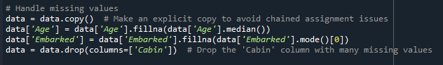 To ensure data quality, I handled missing values by filling or dropping them appropriately. Here’s a look at how I managed this crucial step before moving on to exploratory analysis
- Visualization for EDA 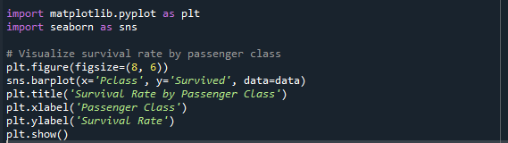 I discovered that passenger class had a significant impact on survival rates, with first-class passengers having the highest likelihood of survival. This insight helped guide feature selection for my machine learning model.
- Code Snippet for Model Training 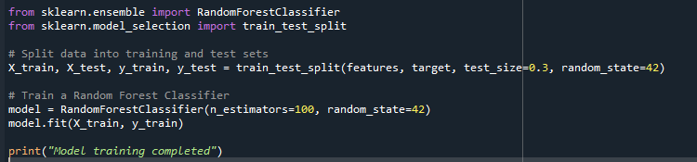 After thorough data analysis, I built a Random Forest Classifier to predict survival outcomes with notable accuracy. Below is a snippet of the training process.
- Visualization for Model Performance 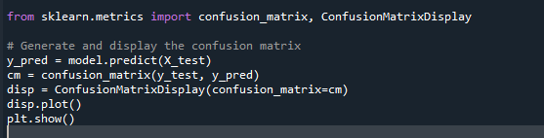
I evaluated my model's performance using a confusion matrix, which provided a clear view of prediction accuracy. This allowed me to fine-tune the model for better results.
Visuals:
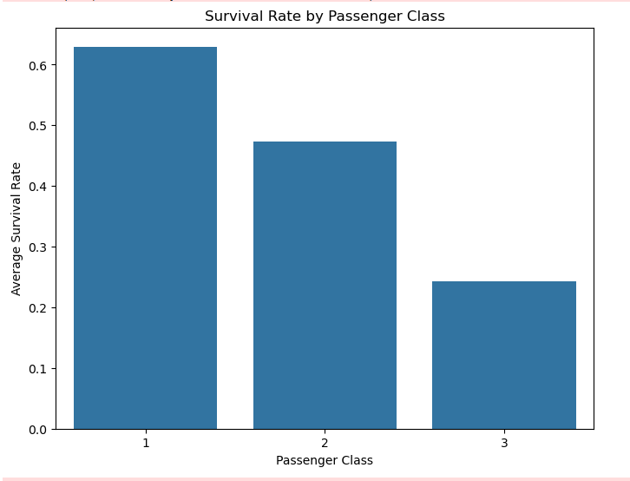
Analysis: The bar chart indicates that passenger class significantly influenced the likelihood of survival. First-class passengers had the highest survival rate, followed by second-class passengers, while third-class passengers had the lowest survival rate. This suggests that socio-economic status played a critical role during the evacuation process, potentially due to better access to lifeboats or prioritized treatment.
Insight: The clear discrepancy in survival rates among the different classes highlights how wealth and class distinctions affected survival outcomes during the Titanic disaster. This finding aligns with historical accounts that higher-class passengers had better survival prospects.

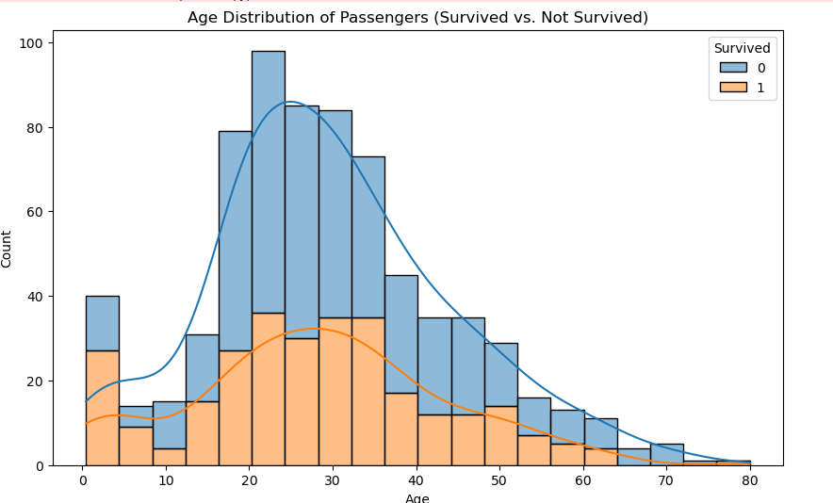 Analysis: The histogram displays the age distribution of passengers and compares those who survived versus those who did not. A notable trend is that children and younger passengers had higher survival rates, as seen by the larger proportion of survivors among the younger age groups. Conversely, older passengers appear to have lower survival rates.
Insight: This pattern supports historical accounts that children were given priority during the evacuation process, aligning with the “women and children first” policy. The distribution also indicates that middle-aged and older passengers faced higher risks, contributing to their lower survival rates compared to younger passengers.
Conclusion
This analysis of the Titanic dataset provided key insights into the factors that influenced passenger survival during the tragic event. By performing data preprocessing, we addressed missing values and prepared the dataset for further analysis. Through exploratory data analysis (EDA), we identified significant patterns, such as the higher survival rates among first-class passengers and female passengers. Visualizations like bar charts, histograms, and heatmaps offered an in-depth look at how age, passenger class, and gender were related to survival outcomes.
The project also demonstrated the use of Python libraries such as pandas, seaborn, and matplotlib to efficiently manipulate and visualize data. These techniques are crucial for understanding data and guiding further predictive modeling.
Overall, this project showcased the importance of thorough EDA and data preprocessing in any data science workflow. The findings and visualizations laid the groundwork for potential machine learning models that could further predict survival outcomes with increased accuracy. Future steps could involve feature engineering, model optimization, and experimenting with various algorithms to enhance predictive performance.
This project not only strengthened data analysis and visualization skills but also provided a practical application of machine learning concepts to real-world data.

